|  |  |  |  |
| --- | --- | --- | --- |
| Name:  Class: | ____________________________________  ________________ | | Date:_________ |
|  | **Year 11 Essentials**  **Major Test Unit 1, 2020** | | / 56  10% |
| **Total Time:** | *55 min TOTAL* |  | |
| **Weighting:** | *10 %* |
| **Equipment:** | *Calculator , Notes page* | | |

|  |
| --- |
| **Question 1** *4* ***marks*** |

Convert the following units.

1. 550 cm to m b) 76.4 mm to cm
2. 16 cm² to mm² d) 176000 m² to km²

|  |
| --- |
| **Question 2*****2 marks*** |

What unit of measurement would you use for measuring:

1. the length of your desk?
2. the length of the school oval?

|  |
| --- |
| **Question 3** ***3 marks*** |

1. Peter has a 2.5 m length of wood that he cuts into five equal lengths. State the length of each piece in cm.
2. If a length of timber is 1.2 m how many pieces of timber are needed to build a square frame that has a perimeter of 6 m?

|  |
| --- |
| **Question 4 *8 marks*** |

Find the **perimeter** and **area** of the shapes below (round to 1 decimal place if necessary):

1. 6cm b)

7.8 mm

3.3.mm

4 cm

6.9 mm

|  |
| --- |
| **Question 6 *6 marks*** |

1. Peter owns two blocks of land. One is 126 m by 92 m and the other is 177 m by 56 m. Which is the bigger block of land?
2. He decides to fence the bigger block of land. How many metres of fence will there be?
3. If fencing costs $12.50 per meter how much will it cost him to fence the bock?

|  |
| --- |
| **Question 7 *2 marks*** |

Using the conversion 1 calorie = 4.2 kilojoules, convert the following:

1. 600 calories = ___________ kilojoules
2. 1500 kilojoules = ___________ calories

|  |
| --- |
| **Question 8 *4 marks*** |

1. Use the formula $v=u+at$ to find the value of $v$, when $u=5$. $a = 4$ and $t=7$.
2. The formula $C=\frac{5}{9}(F-32)$ is used to convert between temperatures in degrees Celsius ($C$) and degrees Fahrenheit (*F*). Find the Celsius equivalent of 50o Fahrenheit.

|  |
| --- |
| **Question 9 *3 marks*** |

After exercising, John counted his pulse rate as 15 beats per 10 seconds.

1. What is John’s pulse rate in beats per minute?
2. John was exercising with Michael who counted his pulse rate as 35 beats per 25 seconds. Who has the lower pulse rate? Show working.

|  |
| --- |
| **Question 10 *2 marks*** |

The pictograph shows how many glasses of water six students drank in a week.

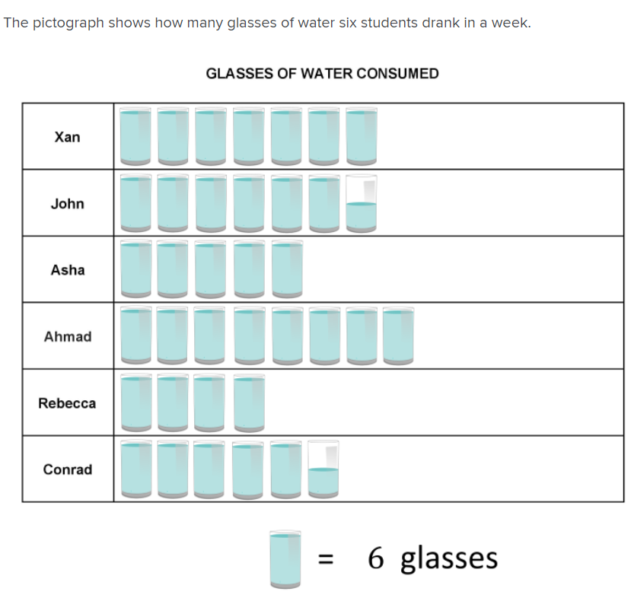

1. How many glasses did Rebecca drink?
2. John drank how many more glasses than Asha?

|  |
| --- |
| **Question 11 *6 marks*** |

30 children were asked which sport they preferred basketball or soccer . Their results are recorded in the table below.

|  |  |  |  |
| --- | --- | --- | --- |
|  | Basketball | Soccer | Total |
| Girls | 12 |  | 18 |
| Boys |  | 7 |  |
| Total |  |  |  |

1. Complete the missing values
2. How many girls prefer soccer?
3. What percentage of children preferred soccer?
4. What percentage of boys preferred basketball?

|  |
| --- |
| **Question 12 *5 marks*** |

The graph below shows the mean temperatures and rainfall over a year for Perth.

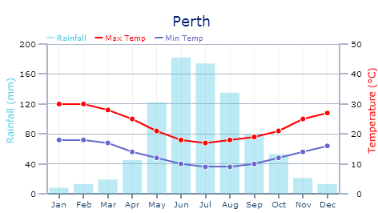

1. What is the mean maximum temperature in September?
2. Which month has the coldest mean minimum temperature?
3. What is the difference between the mean maximum and mean minimum temperatures in September?
4. How much more rain falls in June than December?
5. Describe the annual rainfall pattern?

|  |
| --- |
| **Question 13 *2 marks*** |

Convert the following:

1. 0.3*m3* to *cm3* b)126*mm3* to *cm3*

|  |
| --- |
| **Question 14 *2 marks*** |

A carton of soft drink contains 24 cans. Each can holds 375*mL*. How many litres are there in the carton?

10cm

|  |
| --- |
| **Question 15 *4 marks*** |

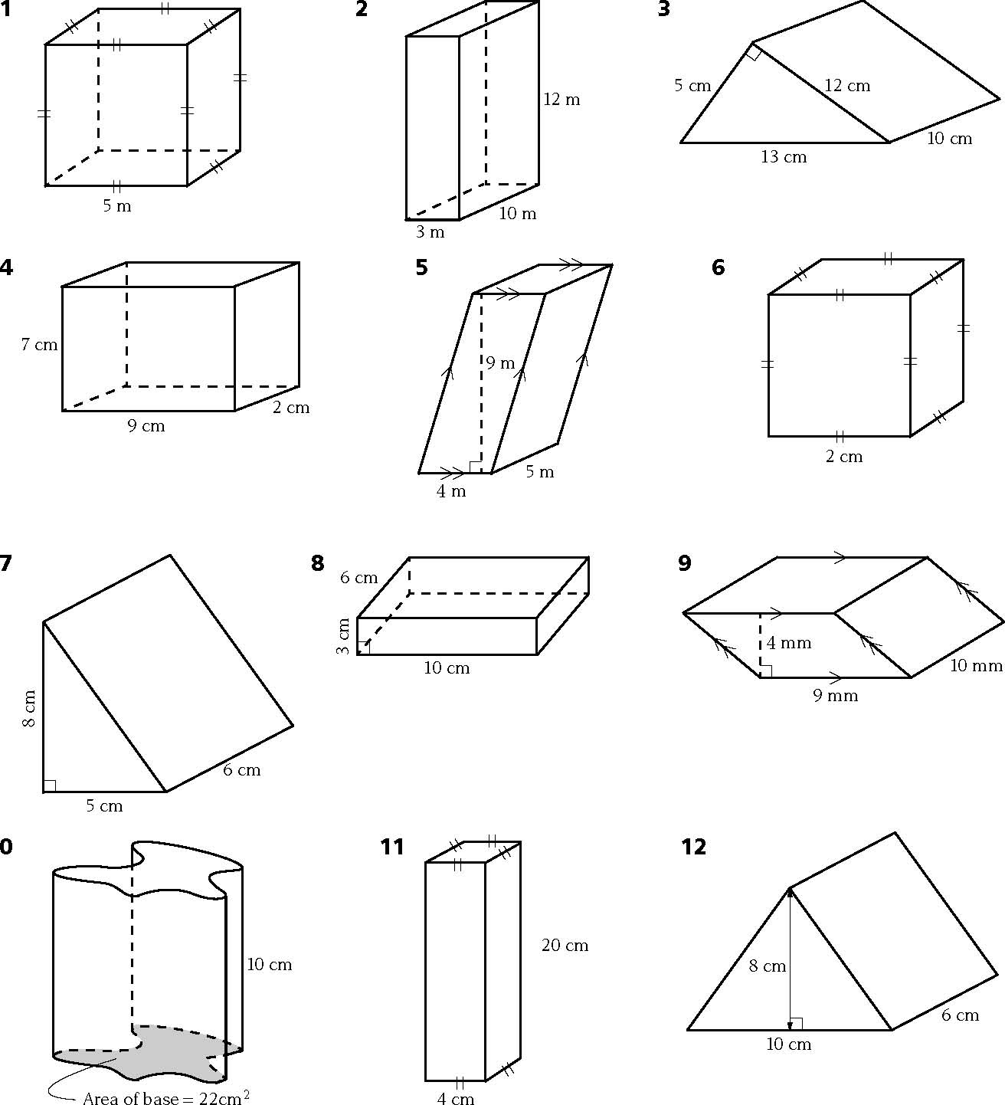Calculate the volume of each prism below.

a)

b**)**

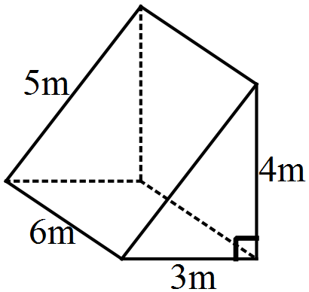

|  |
| --- |
| **Question 16 *3 marks*** |

In times of drought some farmers need to purchase drinking water. Farmer Jack needs to buy water weekly and he does so in a tank in the shape of a rectangular prism. The tanks dimensions are 2*m* by 1·5*m* by 1*m*.

Calculate the capacity of the tank.

**End of Test**